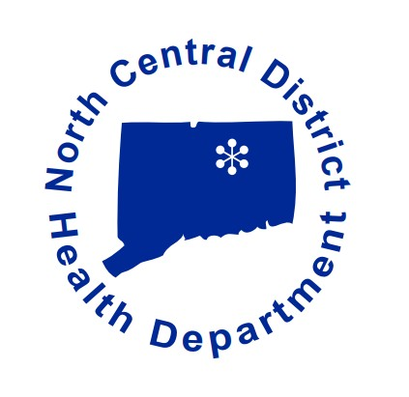

S
Covid-19 Vaccine Appointment Resources

- If you are eligible to receive a vaccine, you can search open clinics through the Vaccine Administration Management System (VAMS). Step-by-step instructions can be found at…
https://portal.ct.gov/Coronavirus/COVID-19-Vaccinations---VAMS-Support

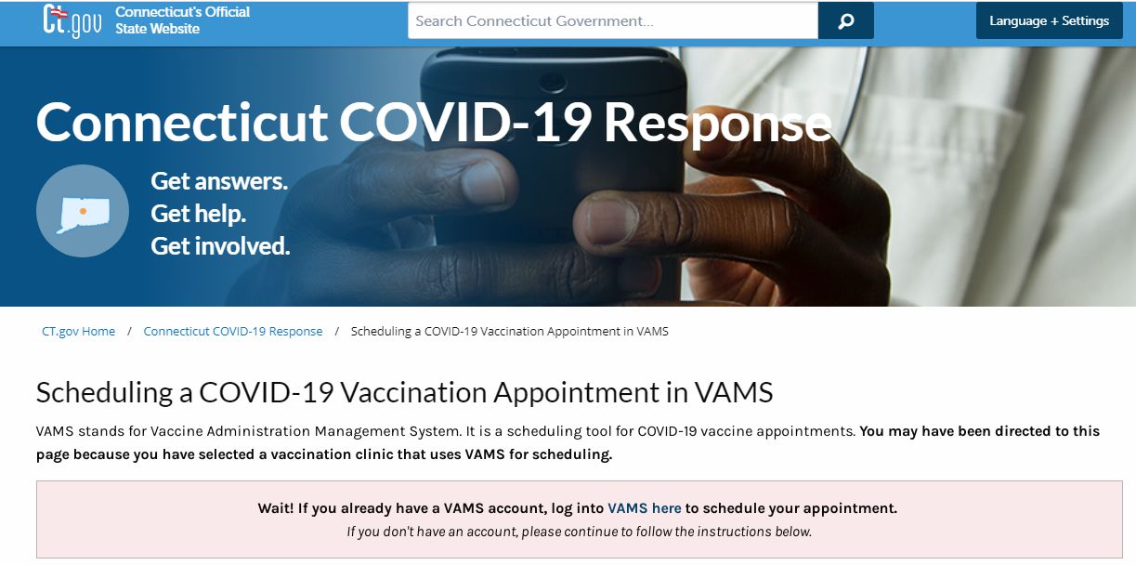

Appointments for Community Health Center Inc. throughout CT and at Rentschler field are scheduled through the VAMS system. Those without access can contact Connecticut’s Vaccine Appointment Assistant Line at 877-918-2224.
- Schedule an appointment through Hartford Healthcare by visiting… https://hartfordhealthcare.org/health-wellness/covid-vaccine/schedule-your-vaccine
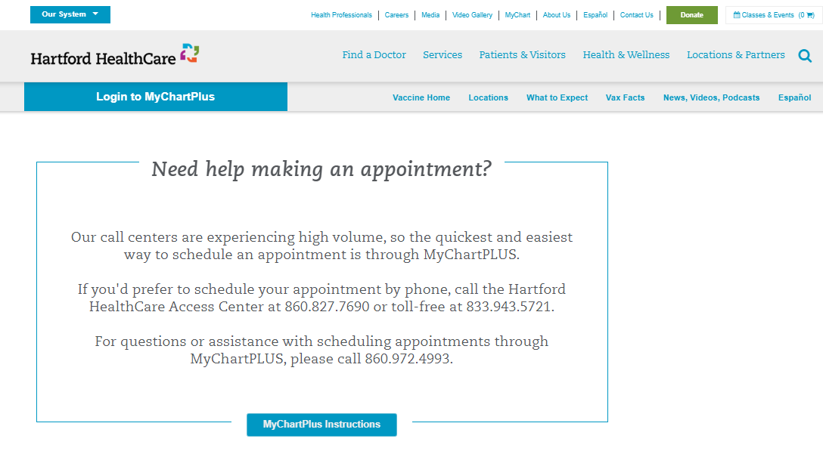

Additional vaccine providers with their own scheduling systems and information on eligibility can be located at…

https://portal.ct.gov/Coronavirus/COVID-19-Vaccination-Scheduling-Options

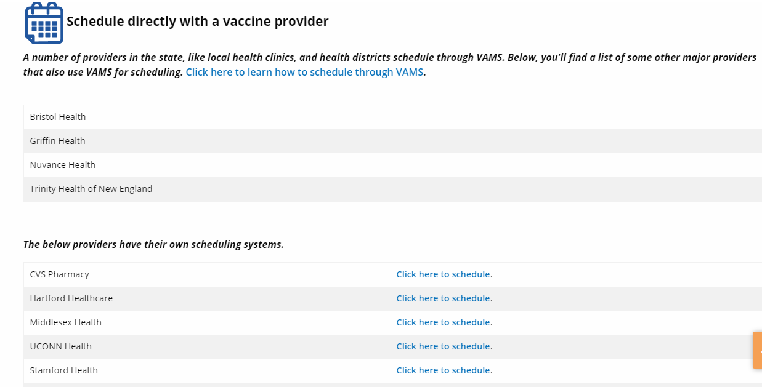

- For assistance in scheduling appointments for senior citizens, please contact the following hotline in your area. Please contact for first dose appointments only!

- Suffield: Suffield Community Aid: (860) 668-1986
- Windsor Locks: (860) 654-8979
- Enfield: (860) 253-6398
- Vernon, Ellington, Stafford, and Somers: (860) 896-4568

Thank You and Stay Safe!

