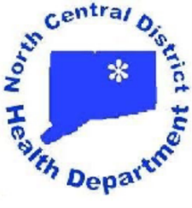
North Central District Health Department
Enfield—31 North Main Street, Enfield, CT 06082 * (860) 745-0383 Fax (860) 745-3188
Vernon—375 Hartford Turnpike, Room 120, Vernon, CT 06066 * (860) 872-1501 Fax (860) 872 1531
Windham—Town Hall, 979 Main Street, Willimantic, CT 06226 * (860) 465-3033 Fax (860) 465-3034
Stafford—Town Hall, 1 Main Street, Stafford Springs, CT 06076 * (860) 684-5609 Fax (860) 684-1768

Patrice A. Sulik, MPH, R.S.
Director of Health

North Central District Health Department
Calendar of Regular Board Meetings
January 2019 - January 2020

****************************************************************************************************
All Board meetings are held the second Wednesday of each month
All Board meetings begin at 7:00 p.m. and end no later than 9:30 p.m.

Enfield meetings are held at the NCDHD Headquarters, 31 North Main Street, Enfield, Connecticut.

Vernon meetings are held in the Conference Room of the NCDHD Vernon Office at 375 Hartford Turnpike, in Vernon, Connecticut

Meeting locations in other towns – to be determined.

***************************************************************************************************

January 9 - Enfield July – NO MEETING

February 13 - Vernon August 14 – Stafford

March 13 - Suffield September 11 - Enfield

April 10 - Vernon *October 16 – East Windsor

May 8 - Windham November 13 - Vernon

June 12 - Ellington December 11 - Enfield

January 8, 2020 - Enfield

