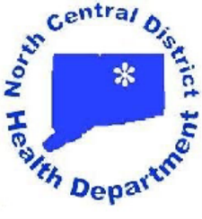
North Central District Health Department
Enfield—31 North Main Street, Enfield, CT 06082 * (860) 745-0383 Fax (860) 745-3188
Vernon—375 Hartford Turnpike, Room 120, Vernon, CT 06066 * (860) 872-1501 Fax (860) 872 1531
Windham—Town Hall, 979 Main Street, Willimantic, CT 06226 * (860) 465-3033 Fax (860) 465-3034
Stafford—Town Hall, 1 Main Street, Stafford Springs, CT 06076 * (860) 684-5609 Fax (860) 684-1768

Patrice A. Sulik, MPH, R.S.
Director of Health

Finance Committee Meeting Minutes
North Central District Health Department
Vernon Office Conference Room
375 Hartford Turnpike
Vernon, Connecticut
Thursday, November 8, 2018
5:00 PM

The meeting was called to order at 5:20 PM.

Maria Whelden, Diane Wheelock, Trish Vayda, Cathy Rebai and Patrice Sulik were in attendance.

The draft proposal of the FY 2019-2020 budget was reviewed and discussed at length. Revisions were recommended for the proposed budget that will be presented to the Board at the November Regular Meeting of the Board.

The meeting was adjourned at 7:45 PM.

